Ansible Configuration Steps

Step1: First you required 1 controller node and n host node (host node could be multiple)

In this case we have 1 Controller Node and 2 Host node

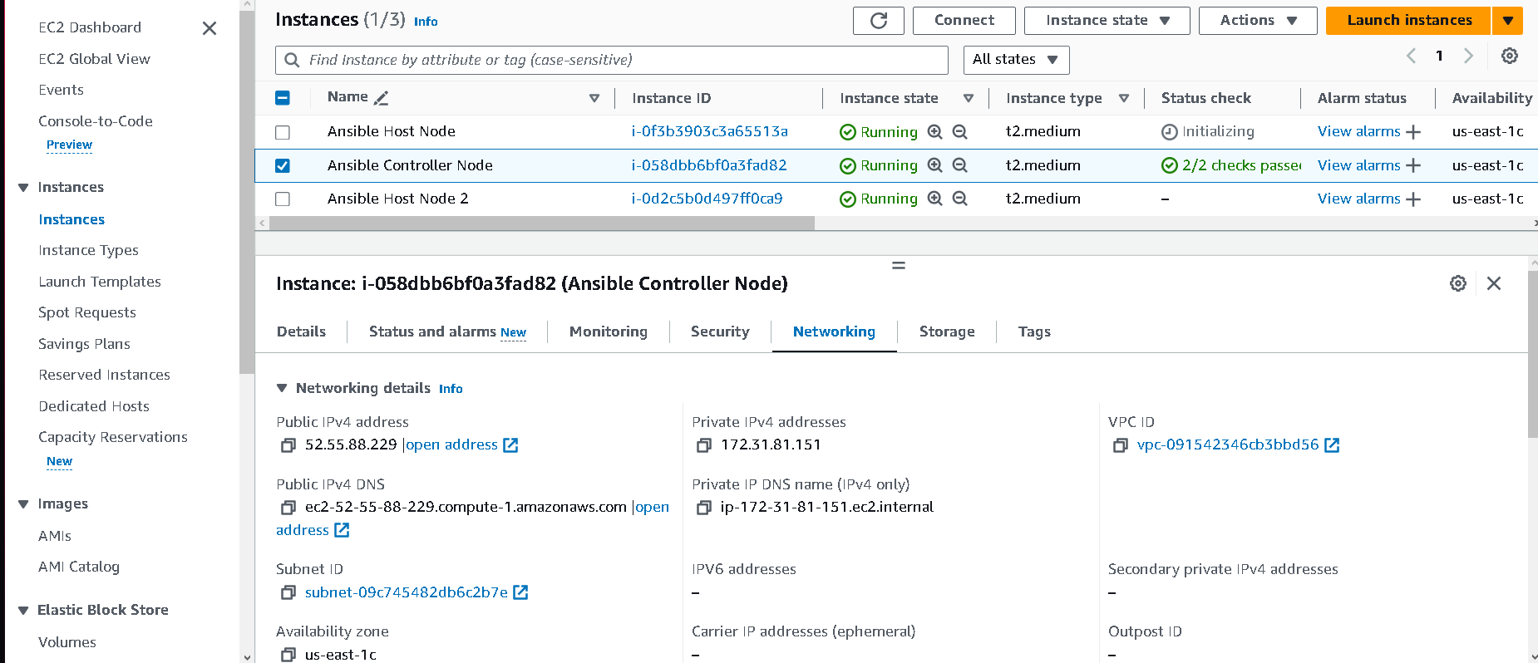

Step2: Open Ansible Controller Node ec2 instance and install ansible here only

$ sudo apt update

$ sudo apt install software-properties-common

$ sudo add-apt-repository --yes --update ppa:ansible/ansible

$ sudo apt install ansible

Step 3: Now navigate to Ansible folder and open hosts file for host node Confg

cd /etc/ansible

sudo vi hosts

Step 4: now create a group SL i.e Simple Learn you could use anything and mentioned private Ip of your host node

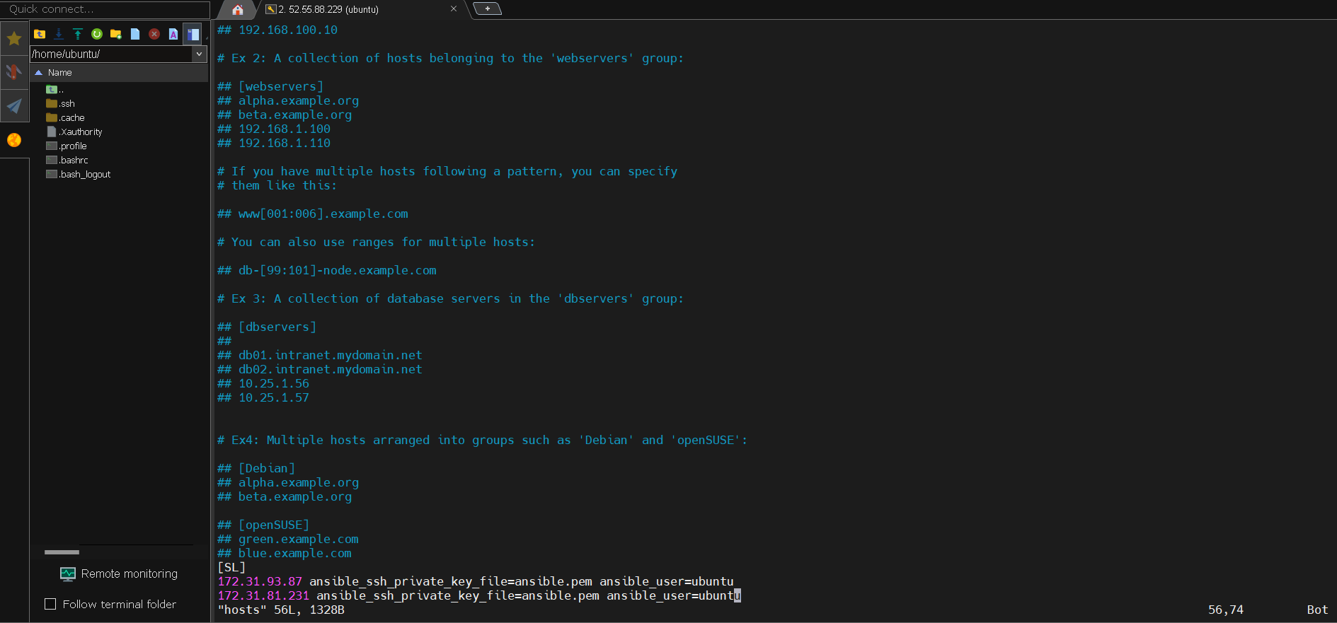

Step 5: We also required .pem file which is used for creating host nodes and controller node

(i) now need to copy .pem key from local machine to our ec2 instance vm server

(ii)now navigate to folder where .pem key is present and open gitbash termical from that folder and enter below cmd

scp -i ansible.pem ./ansible.pem ubuntu@52.55.88.229:/home/ubuntu

scp -i ansible.pem // this will help to authenticate

O/P

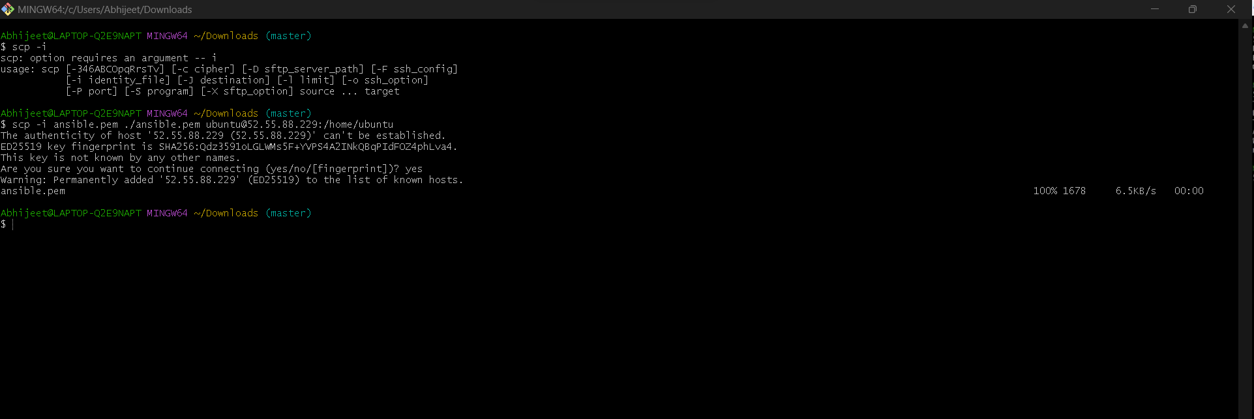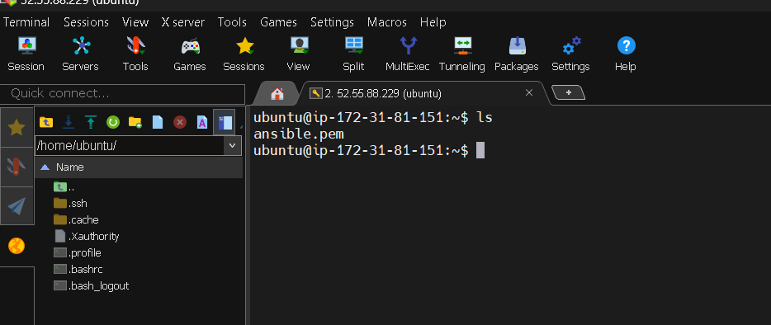

Now check the mode of this file i.e ansible.pem using below command

$ls –la

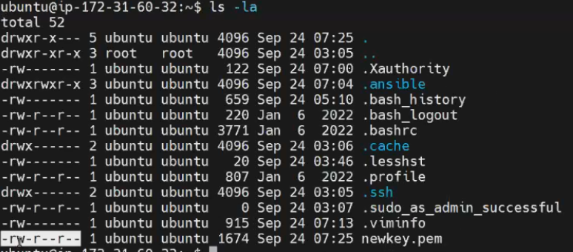

Now change the mod to readwrite only using below command

$ chmod 600 ansible.pem

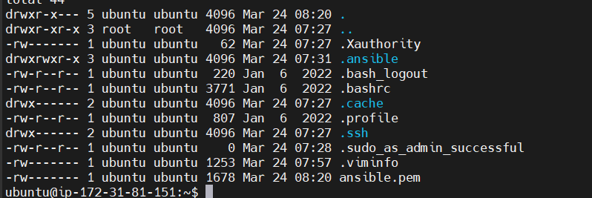

Now edit the host file using below commad and add the key path

sudo vi /etc/ansible/hosts

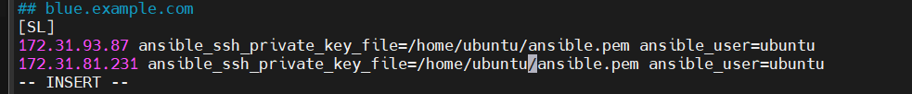

In this way we can authenticate host node using private key i.e .pem file

Step 6: Check everything is perfect using this ping command

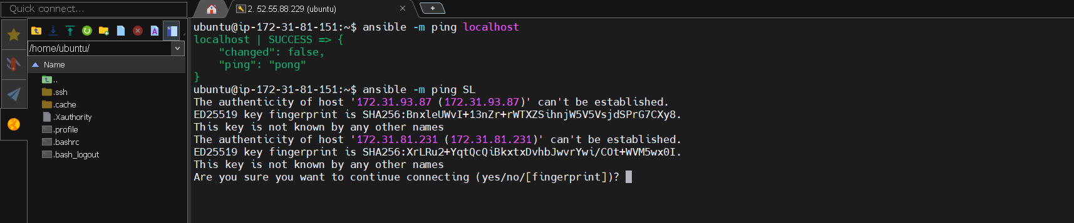

I got error message that is host nodes unreachable

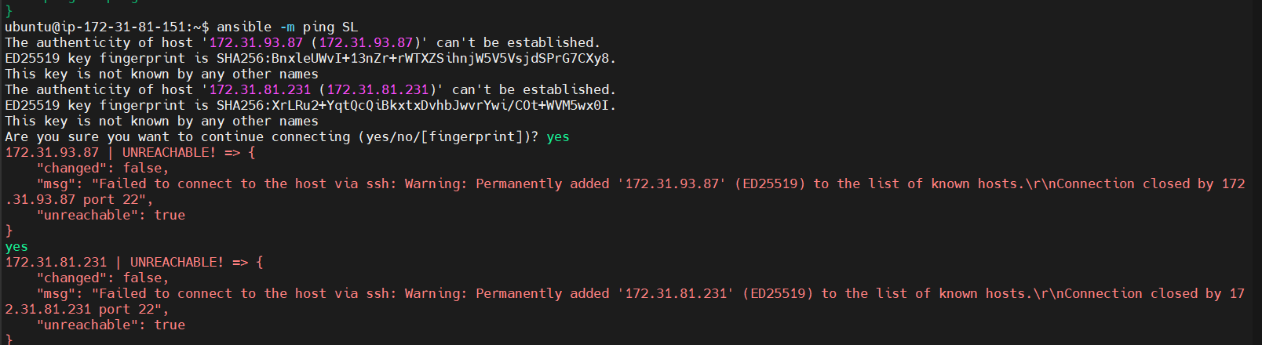

To fix this go to security groups and and edit inbound rule custom_tcp and source my Ip

Note: after adding this cmd ansible -m ping SL make sure type 2 times yes

O/P

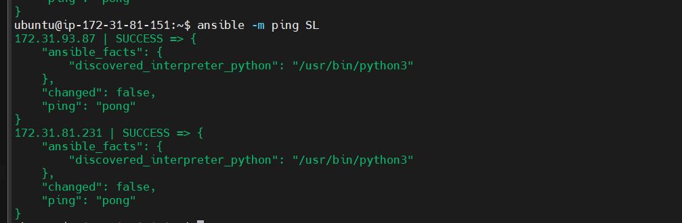

Now you will be able to connect from controller node to these two host nodes

Step 7: Now using Some adhoc commad we will create file in host server

ansible SL -a "touch abhijeet"

Successfully created two file on host nodes

O/P

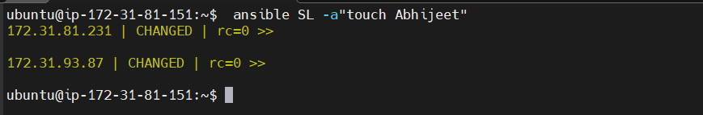

File Abhijeet Created on host node

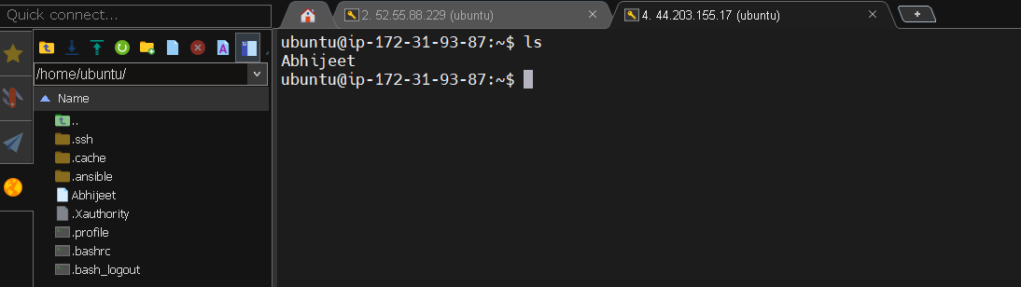

Bonus Part

We can also declare our hosts in Inventory like this

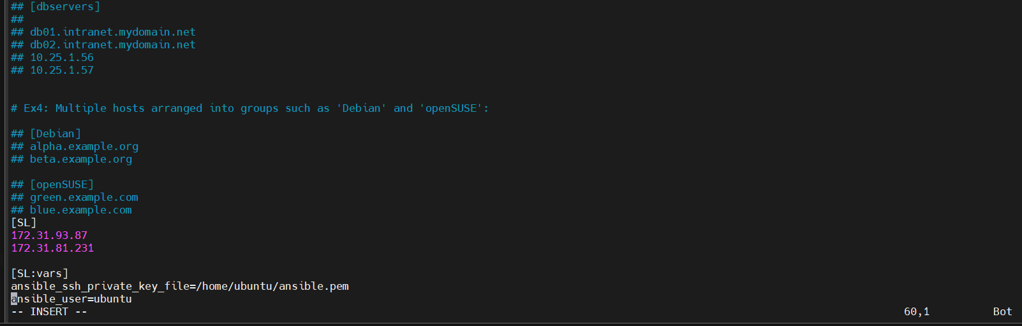

Adhoc commad syntax

$ ansible [pattern] –m [module] –a “[module options]”

You can now also install Docker in hosted nodes

ansible SL -a"sudo apt update -y"

ansible SL -a"sudo apt install docker.io -y"

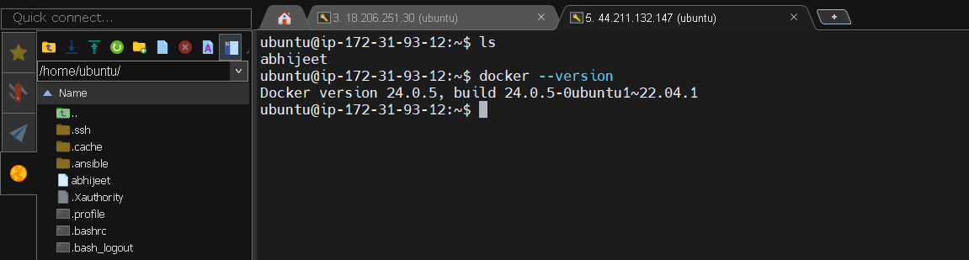

Now we will do adhoc commad with module

ansible SL -m apt -a"name=nginx state=present" –b

check the status of nginx service

ansible SL -m command -a "systemctl status nginx" –b

------------------------- Now see some example of Ansible Play Books ---------------------------

First make directory of ansibleplaybook

mkdir ansibleplaybook

create playbook yaml file

vi firstplaybook.yaml

---

- hosts: SL

user: ec2-user

become: yes

connection: ssh

tasks:

- name: install docker

action: apt name=docker state=present

To run Ansible playbook use following Command

Ansible-playbook firstplaybook.yaml

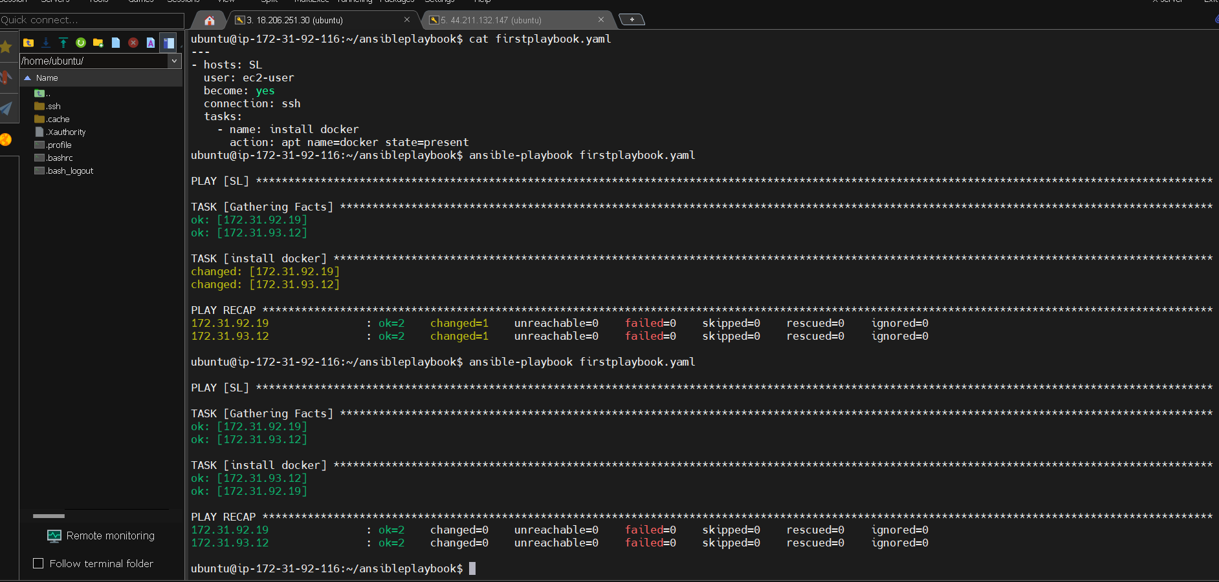

You Can also define multiple tasks

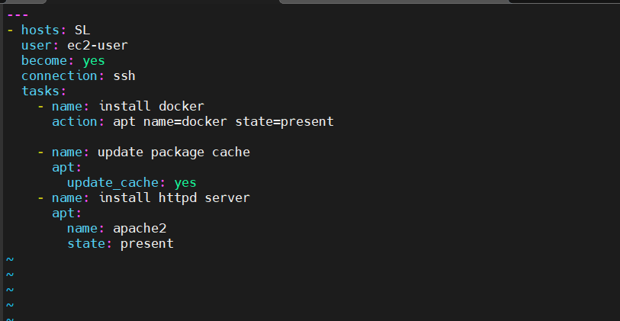

O/p:

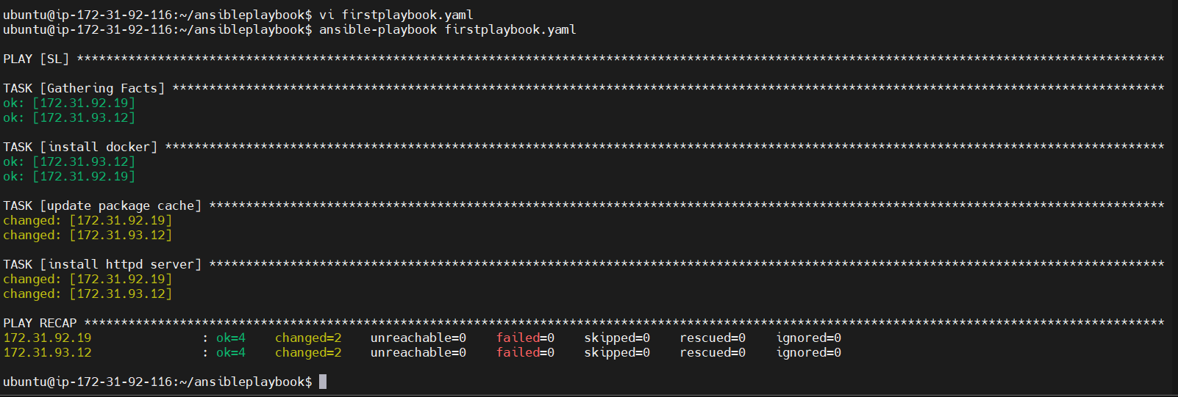

Lets take One more example Uninstall the Docker and Install Maven using Ansible Playbook

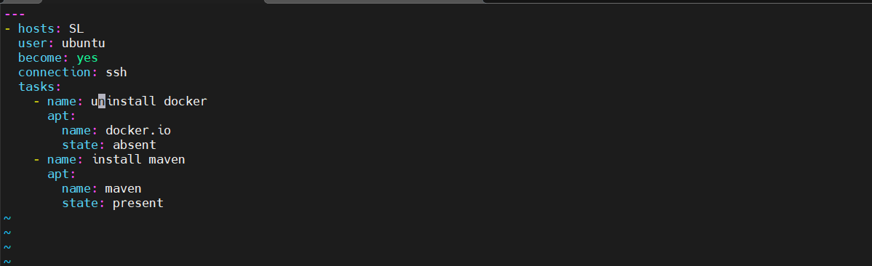

O/p

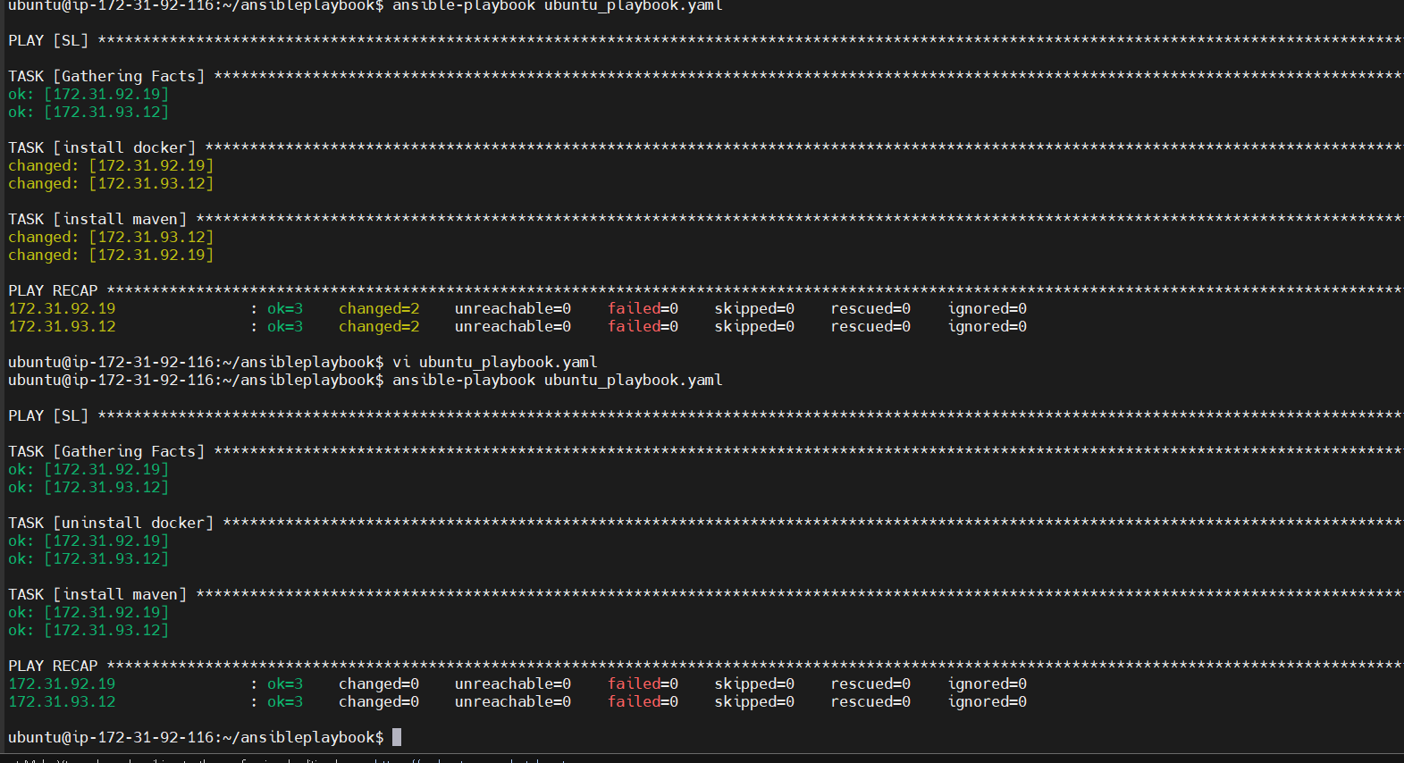

Next example is for handler means host html file on apache server in Ubuntu

vi handlerplaybook.yaml

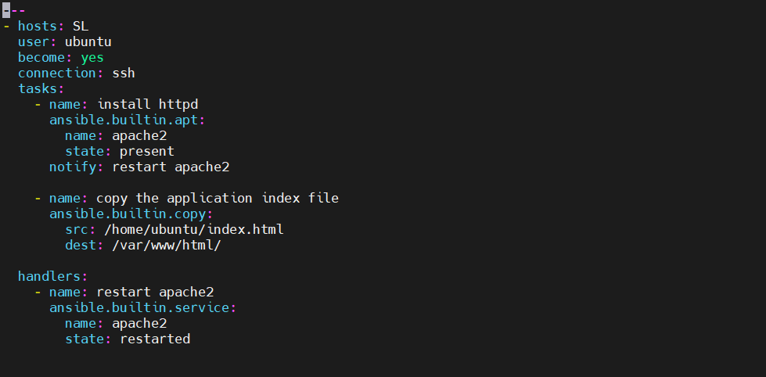

Now run the ansible playbook

$ ansible-playbook handlerplaybook.yaml

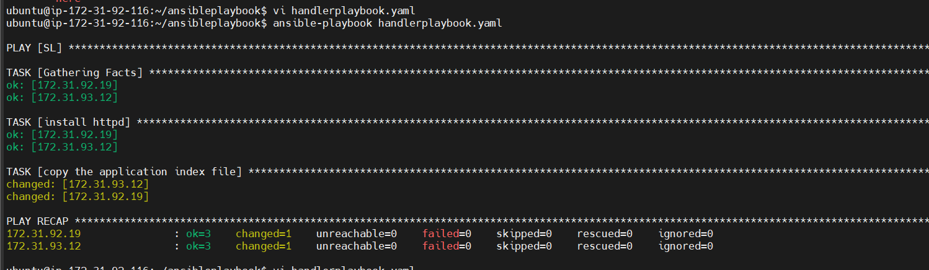

Now you che verify that in host ect2 instance our index.html file is hosted

Open your browser and paste your public ip along with port 80 becase apache2 by- default run on port 80

<http://44.211.132.147:80>

o/p:



You can also check in hosted nodes that index.html file is uploaded in /var/ww/html/ directory

o/p:



Note this script also work but above script was better to view

vi handlerplaybook.yaml

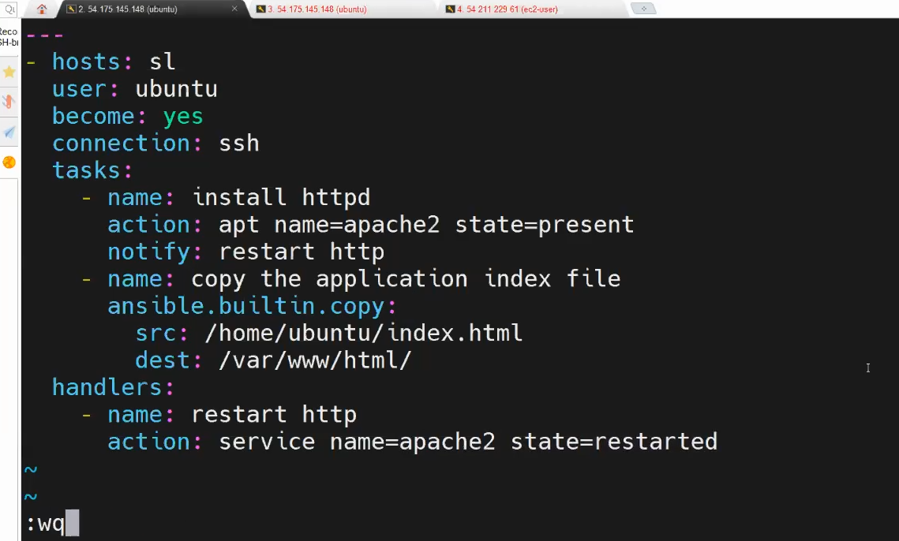

Attension don’t forget to edit security services

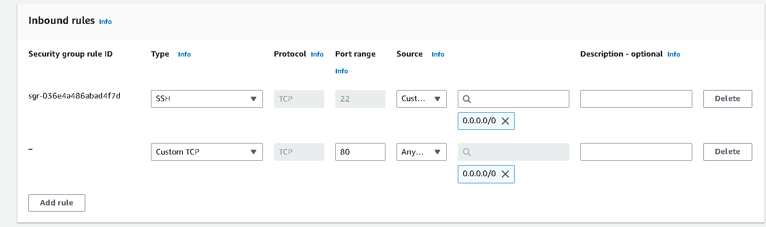

--------------------Lets see how to create roles in Ansible----------------------

What is Ansible roles?

Ans: Ansible Roles provide a structured way to organize tasks, templates, files, and variables. This structure makes it easier to manage complex automation setups, as everything related to a specific role is contained within its directory.

Where to locate roles directory in ansible

$ cd /etc/ansible/roles

Refer roles for documentation from this website

<https://galaxy.ansible.com/ui/>

crete ansible demo-role

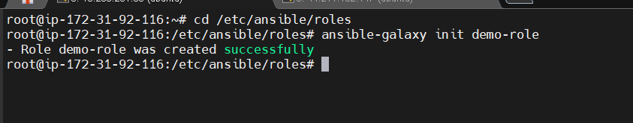

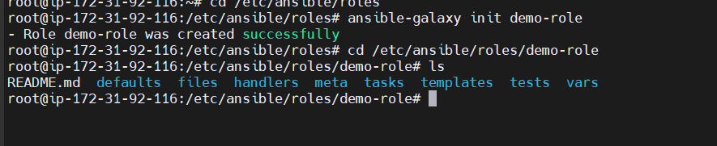

What is the purpose of each directory

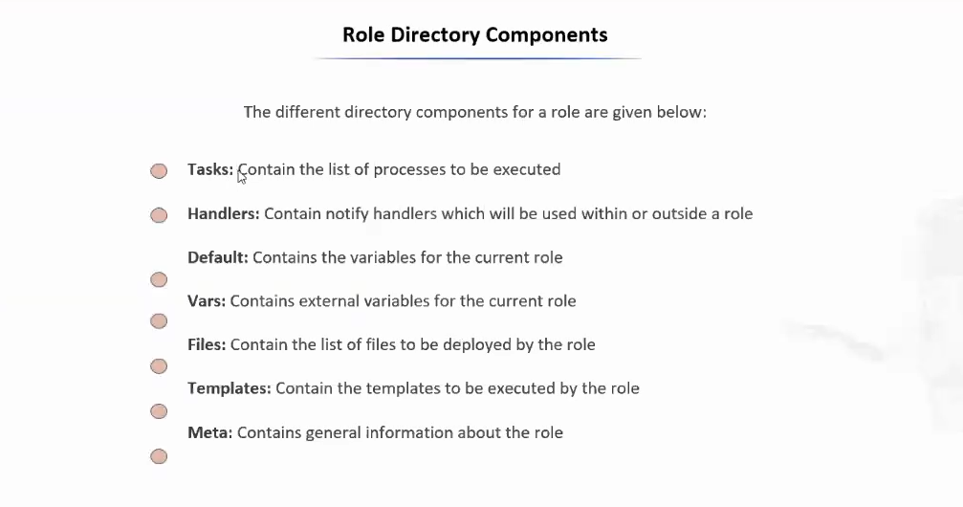

------- Lets host the de-role in nginx server -------

cd /etc/ansible/roles/demo-roles/tasks

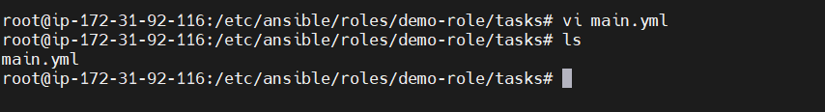

then in tasks folder there is main.yml file modify it

vi main.yml

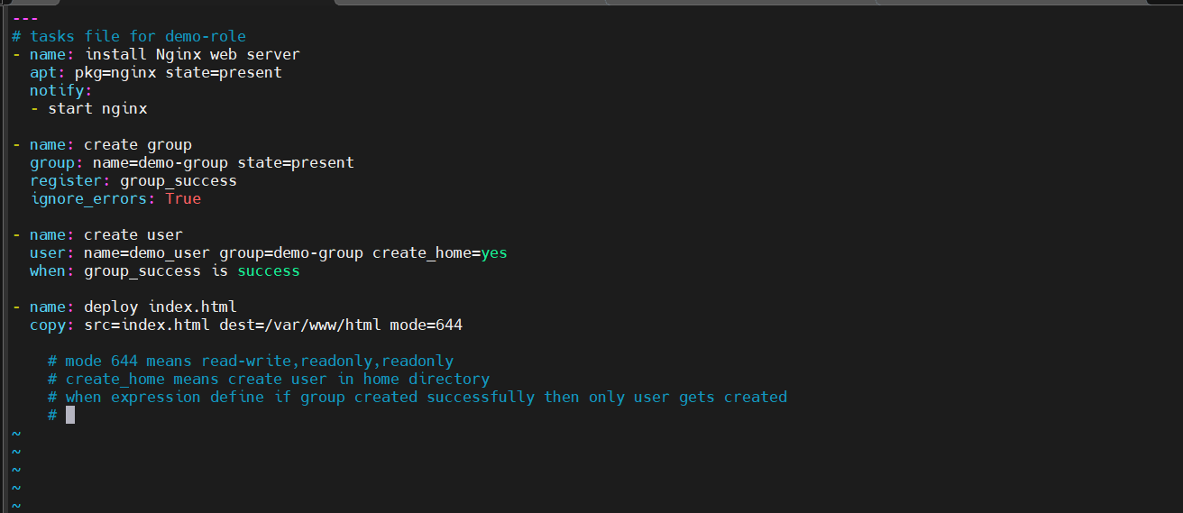

Now change directory to /etc/ansible/roles/demo-role/files#

Create index.html

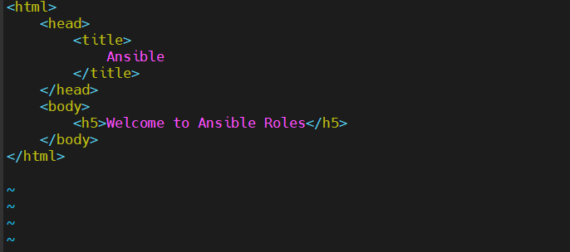

We are done with files folder and tasks folder

Now navigate to handler folder

cd /etc/ansible/roles/demo-role/handlers

do some changes in main.yml

vi main.yml

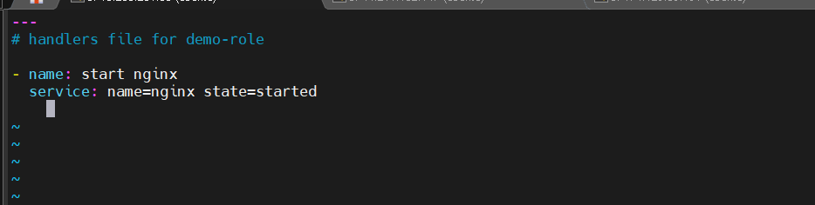

Basically what we have done here

Created index.html file in demo-role/files

Modified main.yml file in demo-role/handlers

Define task in demo-role/tasks

Now final step is apply this created role i.e demo-role

Create nginx role for apply these

First navigate back to roles folder and create nginx.yml file

vi nginx.yml

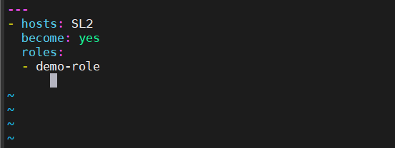

Now dublicate the current tab and add private ip in i.e Ansible host node 3

inside hosts file

create a new group

vi /etc/ansible/hosts

o/p

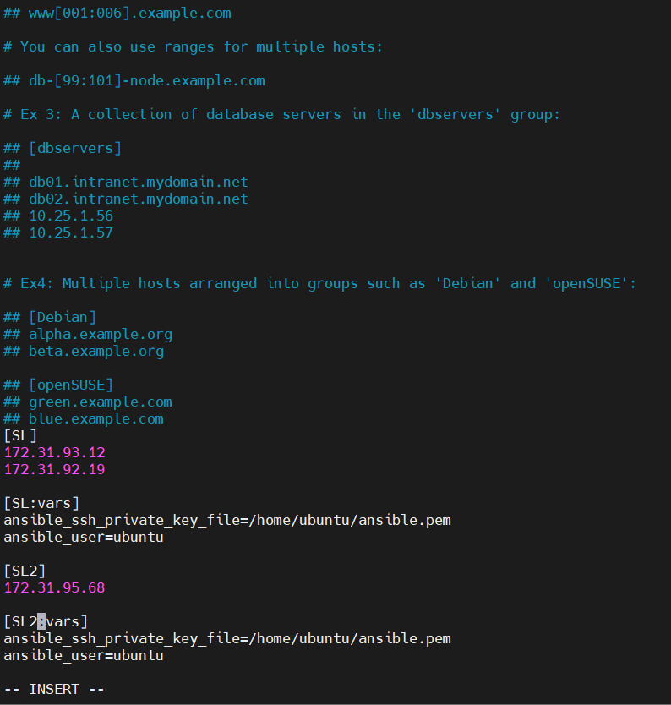

Check to verify the ping newly created vm is connected or not i.e Ansible hostnode 3

$ ansible –m ping SL2

o/p

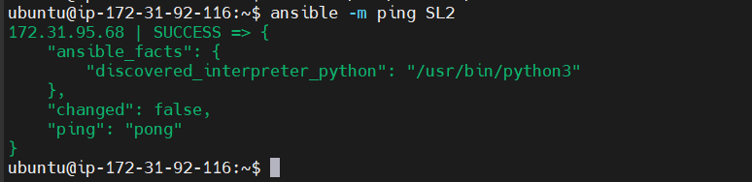

Now run nignx playbook roles

$ ansible-playbook nginx.yml

o/p

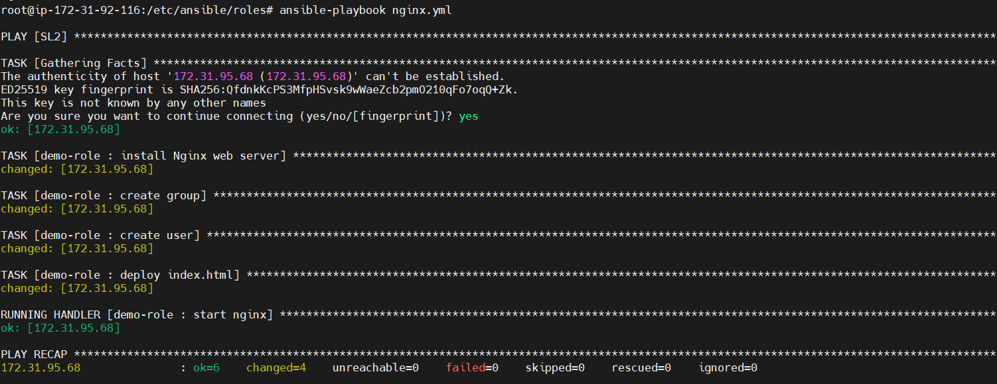

If you get any error while installing nginx then using adhoc command update the package first

$ ansible SL2 –a”apt update -y” –b

Note : only use above command if you get any error then again run playbook file

Finally to test above execution copy public ip of new created vm and paste it on web browser

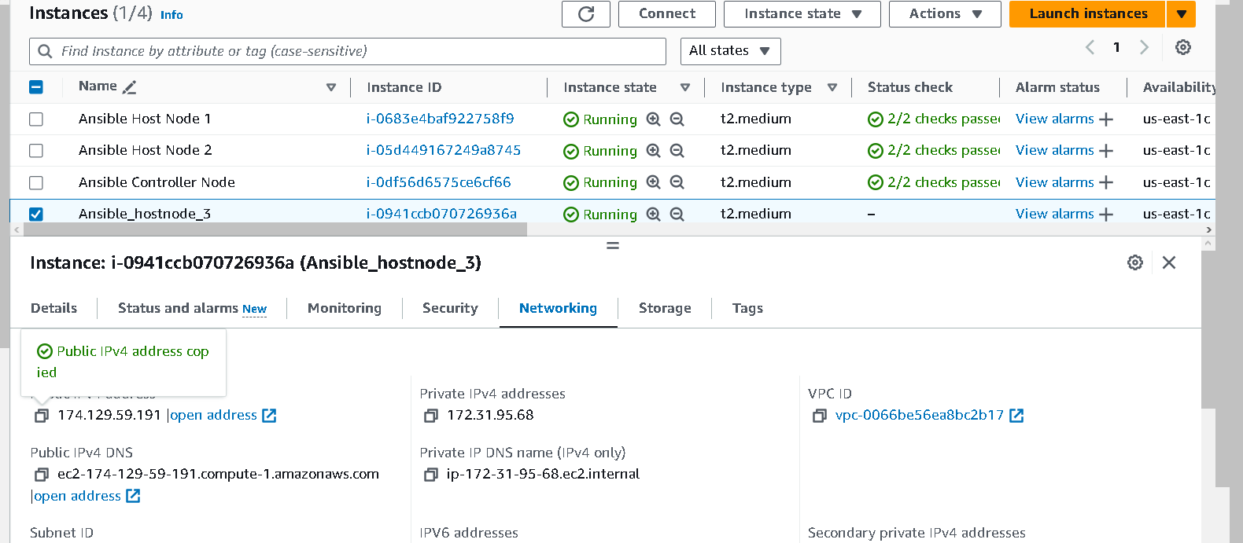

Final output

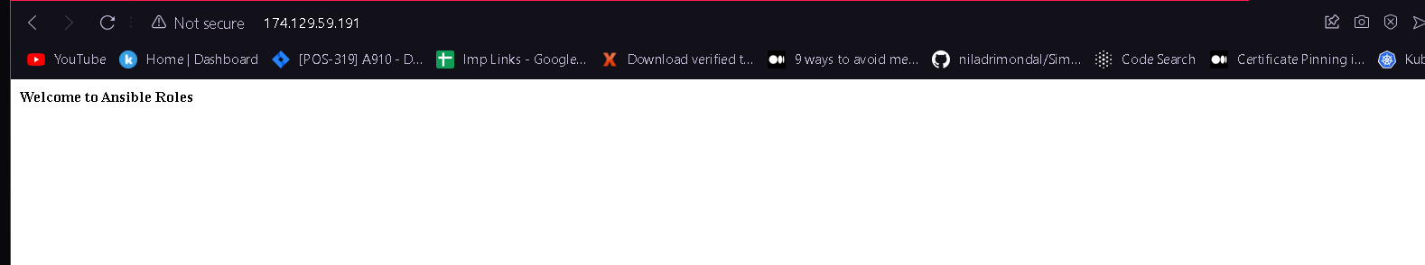

If its how showing or getting dns error then check security group

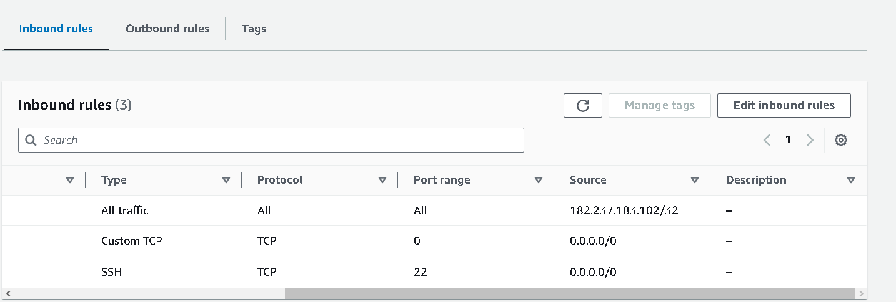

Above output is not fully correct because some syntax in wrong in index.html file

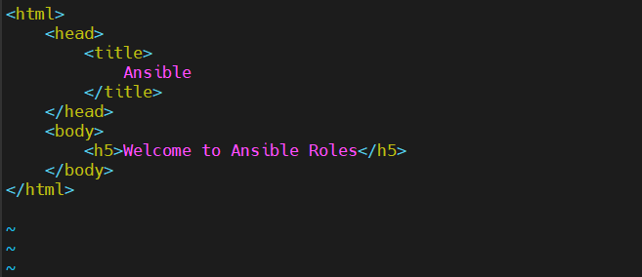

Now its correct

